MILESTONE 1
Project Objective
The primary objective of this project is to design and develop an intelligent, AI-powered Career Recommendation System as part of the Infosys Springboard Internship Program. The system aims to leverage resume analytics and automation technologies to provide personalized and data-driven career guidance.
The key objectives of the proposed system are:
- To implement resume analytics techniques for building an intelligent career recommendation framework.
- To enable users to upload their resumes and automatically extract relevant information such as skills, education, experience, certifications, and achievements using advanced parsing techniques.
- To apply Artificial Intelligence (AI) and Machine Learning (ML) algorithms to analyze resumes and identify strengths, weaknesses, skill gaps, and experience levels.
- To utilize Selenium automation for collecting real-time employment-related data from online job portals.
- To generate accurate and personalized job recommendations by matching extracted resume data with job requirements.
- To develop an intuitive and user-friendly web interface using Streamlit for seamless user interaction.
- To implement a secure database management system for efficient storage, retrieval, and management of user data.

FlowChart
(https://excalidraw.com/#json=zaEBWoTlILrA_wwA_tZw8,2JjBJOgmp8AKNfi2b-v-Jg)
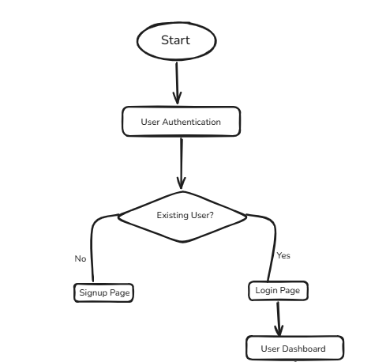

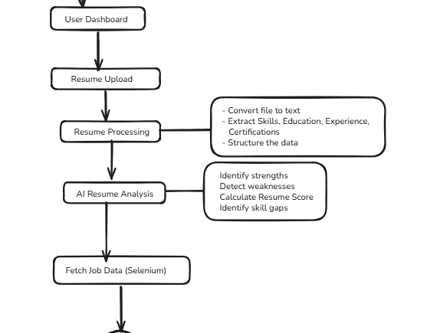

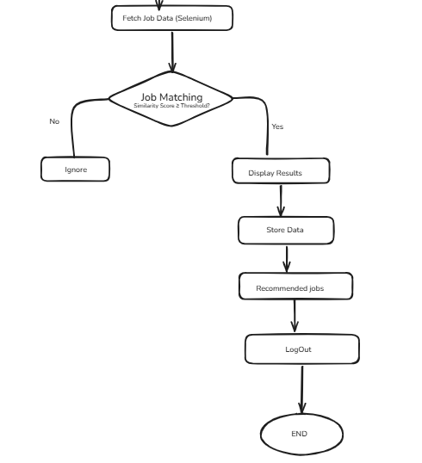

Pseudo Code:
START

1. Initialize System
- Connect to Database
- Load AI/ML Model
- Initialize Streamlit Interface
- Initialize Selenium WebDriver

2. Display Login / Signup Page

3. IF user selects Signup THEN
INPUT name, email, password
IF email not already registered THEN
Store user details in database
Display "Signup Successful"
ELSE
Display "User Already Exists"
ENDIF
Redirect to Login
ENDIF

4. IF user selects Login THEN
INPUT email, password
Validate credentials from database
IF valid THEN
Go to Dashboard
ELSE
Display "Invalid Credentials"
Return to Login Page
ENDIF
ENDIF

5. Dashboard
Display options:
- Upload Resume
- View Previous Reports
- Logout

6. IF user selects Upload Resume THEN
INPUT resume_file (PDF/DOCX)

// Resume Processing
Convert resume to text
Extract:
- Skills
- Education
- Experience
- Certifications
- Projects

Store extracted data in structured format

// Resume Analysis
Analyze strengths
Identify weaknesses
Detect skill gaps
Calculate resume_score

7. Fetch Job Data using Selenium
Open job portal
Search jobs using extracted skills
Scrape:
- Job Title
- Required Skills
- Experience Required
- Location
Store job data in database

8. Match Resume with Jobs
FOR each job in job_database DO
similarity_score = compare(resume_skills, job_required_skills)

IF similarity_score ≥ threshold THEN
Add job to recommended_list
ENDIF
END FOR

9. Rank Jobs
Sort recommended_list by similarity_score (Descending)

10. Display Results
Show:
- Resume Score
- Strengths
- Weaknesses
- Skill Gap Suggestions
- Top Recommended Jobs

11. Store analysis results in database

12. IF user selects Logout THEN
End session
ENDIF

END

